Chapter 9: pp. 236-237 (4th edition), 238-239 (5th edition), Nos. 2*, 3, 4, 5, 6

Design Turing machines for the following languages by drawing the transition graph for each Turing machine.

3) Determine what the Turing machine in example 9.7 does when presented with the inputs “aba” and “aaabbb”.

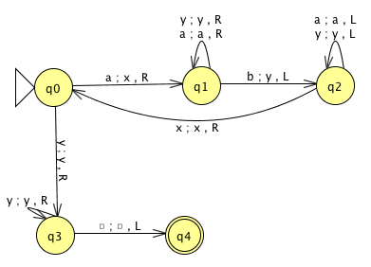
This TM machine accepts the language {a^{n}b^{n}: n ≥ 1}, and therefore we can clearly see that both given strings are rejected.

First, in the case of aba, the “a” and the matching “b” are marked, and since there are no more a’s at the beginning, the machine goes into state q₃. Here, it sees an “a” at the end, before getting to the first blank on the right, and it dies in state q₃.

Second, in the case of “aaabbbb”, something similar to the above case happens because there is one unmarked b still on the tape at the end.

4) Is there any input for which the Turing machine in example 9.7 goes into an infinite loop?

No, there is not.
Each loop on the three of the states “q1, q2, q3” has to end when they get to the correct symbol “b, x, and or blank” on the tape. The only other major loop must end at the latest when the last “a” has been matched by a b and, since there are no more a’s, it must exit the loop.

5) What language is accepted by the Turing Machine whose transition graph is in the figure below?
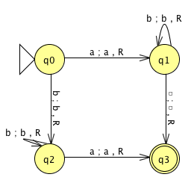
This Turing Machine never changes the tape and always moves to the right.

The transition from q0 to q1 leads to the acceptance of any string of the form ab*.

The transition form q₀ to q₂ accepts strings that begin with a b, which is followed by a combination of b’s and then followed by a single a (bb*a).

Finally, the machine dies in the accepting state without having read any remaining symbols. As a result, an “a” can be followed by any string of a’s and b’s. The path accepts bb*a(a+b)*. Therefore, the language of this machine is ab* + bb*a(a+b)*.

6) What happens in ex 9.10 if the string w contains any symbol other than 1?
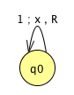
If a symbol other than a 1 is encountered, the machine halts in state q₀.

Assume the input alphabet is {a, b}.

1. A TM that accepts the languages of all strings that contain the substring bbb.

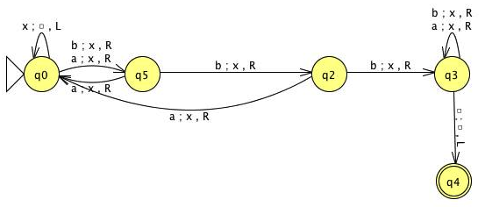
2. A TM that accepts the languages of all strings that do not contain the substring bbb.
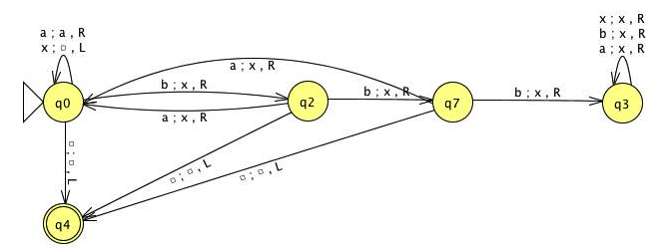
3. A TM that accepts the language of odd length palindromes.
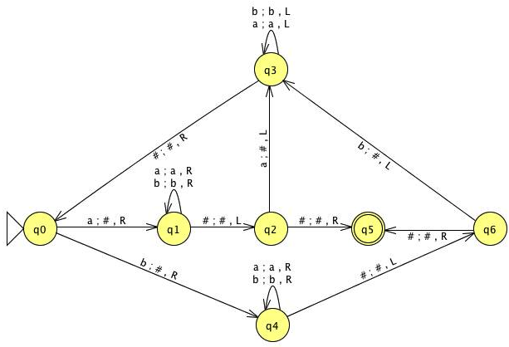

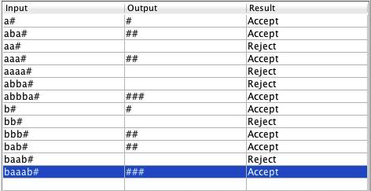

4. A TM that accepts all strings with more a’s than b’s.

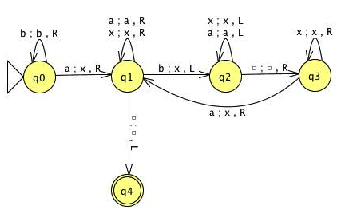

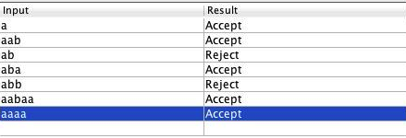

5. A TM that accepts the language { a^{n} b^{n+1}: n ≥ 0}.

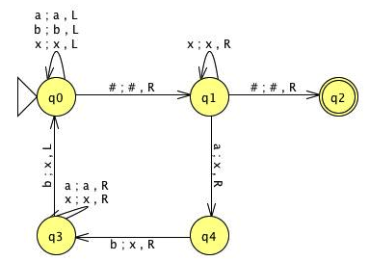

6. A TM that accepts the language { a^{n} b^{n+2}: n ≥ 0}.

